To: | Kurt Moldrup, Interim Director
Thru: | N/A
From: | Lieutenant L. Breault
Position: | Internal Affairs | Division: | Office of the Director
Report Title: | Internal Affairs Annual Summary
Rpt Freq./Year: | Annual / 2021
Policy #: | 52.1.5
Date: | January 21, 2022

Policy:

The Internal Affairs Officer will complete and submit to the Director an annual overview. This report will recap the past year’s activities, a statistical analysis, analysis of complaint areas, and resolution of cases.

Investigations:

In 2021, the Internal Affairs Section received forty-three (43) cases for investigation:
Seven (6) cases were reported by members of the public and involved:
  - Nine (9) Police Officers
  - Zero (0) Support Personnel
  - Zero (0) Corrections Officer
- Thirty-Seven (37) cases were reported internally and involved:
  - Thirty-Two (32) Police Officers
  - Five (5) Correction Officers
  - One (1) Dispatcher
  - Four (4) Support Personnel (Includes PSA’s)
  - Zero (0) Administrative Personnel

The following chart details the last five (5) years of Internal Affairs cases:

Total IA and AA Filings the Past Five Years:

IA AA Total
2017 11 22 33
2018 9 21 30
2019 7 17 24
2020 7 24 31
2021 6 37 43

2021 Complaints by Quarter:

2021 Types of Complaints:

Allegations | Allegation Total | Unfounded | Exonerated | Unsubstantiated | Improper Conduct | Disposition Pending
Failure to Take Appropriate Action | 2 | 1 |  |  | 1
Obedience to Policies | 3 |  |  |  | 3
Collection of Evidence Property | 4 |  |  | 2 | 2
Reporting for Duty | 1 |  |  |  | 1
Use of Force | 2 |  | 2
Submission of Reports
Courtesy | 1 |  |  | 1
Operation of Department Vehicles | 16 |  | 2 |  | 14
Neglect of Duty
Dissemination of Information
Misdemeanor Crime | 4 |  |  |  | 4
Escape of Prisoners
General Rules of Conduct
Supervision | 1 |  |  |  | 1
Abuse of Alcohol While Off-Duty | 2 |  |  |  | 2
Use of Department Computer
Discrimination | 1 |  | 1
Felony Crime
Insubordination
Immoral Conduct | 1 |  |  |  | 1
Conformance to Laws | 5 |  |  |  | 4 | 1
Unprofessional Conduct
Truthfulness
Care of Department Equipment | 4 |  |  |  | 4
Total: | 47 | 1 | 5 | 3 | 36 | 1

Allegations Reflected Above:
In regard to the allegations listed above 6 resulted in investigations that were initiated because of allegations made by the public. 37 of the incidents resulted in investigations due to internal reviews. Some of the complaints and/or investigations revealed the accusation of more than one policy violation. Due to the reflection of multiple violations within some investigations the number of charges may be greater than the total number of investigations. The number of personnel involved will also often be higher than the number of allegations because in someone instances multiple agency members were involved.

2021 Complaint Dispositions:

2021 Complaint Dispositions:
The previous graph obviously indicates that most dispositions result in a finding of improper conduct. The reason for this is that a majority of the complaints received by the Internal Affairs Office are a result of internal actions. Many of which are a result of incidents in which some type of violation of policy have already occurred and thus a complaint is filed by a supervisor who has become privy to a violation of policy taking place. The figures below also reinforce the previous assertion.
Dispositions IA AA
No Action 5 5
Counseling 0 7
Oral Reprimand 0 0
Written Reprimand 1 18
Suspension w/out Pay 0 3
Suspension (HIA) 0 0
Dismissed 0 0
Resigned 0 3
Disposition Pending 0 1
Total: 6 28
* (HIA) Suspension Held in Abeyance *

IA Conclusions Total
Unfounded 1
Exonerated 1
Unsubstantiated 3
Improper Conduct 1
Conclusion Pending 0

AA Conclusions Total
Unfounded 0
Exonerated 3
Unsubstantiated 2
Improper Conduct 32
Conclusions Pending 0

Demographics:

Our department is responsible for policing all of the Riley County area which is made up of 622 square miles. The 2014 US Census Bureau estimates the population for our policing area as 75,194 people and the race profile is as follows:
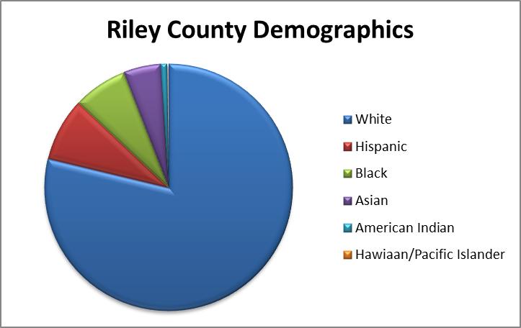
Race | %
White | 77.1
Hispanic | 8.1
Black | 6.9
Asian | 4.8
Native American | 0.8
Hawaiian/Pacific Islander | 0.2

Demographic Breakdown of Complainant by Race & Gender:
Race Total
White 5
Hispanic 0
Black 1
Asian
Native American
Hawaiian/Pacific Islander

Gender Total
Male 5
Female 1

Analysis:

In 2021, we received six (6) complaints from members of the public; we received seven (7) complaints from the public in 2020. Those 6 complaints involved some allegations that had to be investigated as actions which had the potential to contain multiple policy violations. Considering that during the calendar year 2021 RCPD received 54,756 calls for service the number of complaints from the public should be considered as very low. It should be understood that of the 54,756 calls for service 8,677 were playbook activities, 6,596 were traffic stops and 1451 were instances where an RCPD officer conducted a standby during a flight at the airport. Playbook activities are proactive crime fighting measures used by RCPD patrol personnel to place our uniformed personnel in places where past crime data suggests a crime may be more likely to occur or other activity which is utilized in an attempt to reduce crime. Playbook activities do not always include interaction with the public. It may or may not include interaction with the public and the department does not currently engage in tracking of this type for these incidents. It should also be considered that if the playbook data was removed the total number of calls for service would be 46,079. The interaction with the public for these incidents may be limited to a simple phone interaction with a dispatcher. Alternatively, the call for service could require an officer or officers to interact with a large number of people. The data may also be misleading in regard to the number of people our officers interact in which no record exists. An example of this type of interaction may include someone approaching an officer with a question when they are out in public or simply a conversational interaction. The number of these types of interaction would be impossible to quantify.
Our arrest data indicates that 1,735 people were arrested and booked into the Riley County Jail. Of the 1,735 people booked into the Riley County Jail 1,520 were persons arrested by RCPD officers. The other 215 people were arrested by agencies such as but not limited to the Kansas Highway Patrol and Kansas State University Police Department. This arrest number includes probable cause arrests, warrant arrests and juveniles who were taken into custody. This number does not include those who issued a notice to appear, those who were forced to appear before a court under the power of a summons, those who were sentenced and remanded in our custody and those that were detained and released.
In reviewing the complaints filed and internal administrative action I found no alarming trends or patterns that would suggest bias. I would also conclude that due to the very low number of external complaints that the number is so low that statistical relevance may be questioned because of the low sample size.
Our department utilizes an Early Warning System (EWS) to identify employees who by virtue of engaging a pattern of behavior or misconduct may need active engagement to resolve an issue or issues. The criteria to initiate the EWS are to have two substantiated IA/AA complaints within a quarter or four substantiated IA/AA’s in one year. In 2021, we initiated zero (0) EWS case based on the aforementioned criteria.
The following chart depicts how many members of the public or supervisors initiated complaints against employees. Each complaint may involve only one allegation or multiple allegations of misconduct by an employee therefore the conclusion of facts may exceed the number of complaints.

CALEA Proof:
Complaints & Internal Affairs Investigations
External | 2019 | 2020 | 2021
Citizen Complaint | 7 | 7 | 6
Improper Conduct | 0 | 0 | 1
Unsubstantiated | 4 | 2 | 3
Unfounded | 0 | 0 | 1
Exonerated | 3 | 5 | 1
Internal
Internal Complaint | 17 | 24 | 37
Improper Conduct | 12 | 20 | 32
Unsubstantiated | 4 | 3 | 2
Unfounded | 0 | 0 | 0
Exonerated | 1 | 1 | 3

Note: Each complaint may have involved more than one employee where one employee was founded and the other unfounded or may involve more than one policy violation.

